**\*\*PLEASE SAVE PAPER! PRINT DOUBLE SIDED AND ONLY THE PAGE/S WITH YOUR INFORMATION.\*\***

**CSUF DEPARTMENT OF BIOLOGICAL SCIENCE**

**GRADUATE STUDENT – BIOL598 and BIOL599 REQUEST FORM**

*Meet with thesis adviser to complete this form no later than the 1st week of classes.* ***Return it, signed, to Karen Lau.***

|  |  |  |  |  |  |
| --- | --- | --- | --- | --- | --- |
|  | |  | | |  |
| Graduate Student Name (Last, First) | | CWID | | | For Semester & Year |
|  | |  | | |  |
|  | **@csu.fullerton.edu** | | |  | |
| CSUF **STUDENT** Email Address | | |  | Print Adviser Name | |

**A. BIOL599 Independent Graduate Research – 1-3 units per semester; 12 units max.**

(BIOL599 is a lab class and requires a signed Laboratory and Field Safety Procedure Form. See page 4.)

|  |  |  |  |  |  |  |
| --- | --- | --- | --- | --- | --- | --- |
| Course# | Sect# | Class# | Units |  | Total # of 599 Units **listed** on ***Approved*** GSP | Total # of 599 Units **taken** (not going to take), so far |
| BIOL599 |  |  |  |  |  |  |

1. Describe the current status of your research project, including the work you have completed and the work still remaining. (150 words).

|  |
| --- |
|  |

2. List your specific research plans and goals for the upcoming semester; these should reflect the number of units taken (1-3). **Your course grade in BIOL599 will be based on your progress toward successfully meeting these goals during the semester**. (150 words).

|  |
| --- |
|  |

**\*\*PLEASE SAVE PAPER! PRINT DOUBLE SIDED AND ONLY THE PAGE/S WITH YOUR INFORMATION.\*\***

**CSUF DEPARTMENT OF BIOLOGICAL SCIENCE**

**GRADUATE STUDENT – BIOL598 and BIOL599 REQUEST FORM**

*Meet with thesis adviser to complete this form no later than the 1st week of classes.* ***Return it, signed, to Karen Lau.***

|  |  |  |  |  |  |
| --- | --- | --- | --- | --- | --- |
|  | |  | | |  |
| Graduate Student Name (Last, First) | | CWID | | | For Semester & Year |
|  | |  | | |  |
|  | @csu.fullerton.edu | | |  | |
| CSUF Student Email Address | | |  | Print Adviser Name | |

**B. BIOL598 Thesis – 1-3 units per semester; <6 units max., as approved on your GSP**

Students enroll in thesis units after they have completed their 1st Committee Meeting, when they are completing or have completed data collection and are preparing their thesis.

|  |  |  |  |  |  |  |
| --- | --- | --- | --- | --- | --- | --- |
| Course# | Sect# | Class# | Units |  | Total # of 598 Units **listed** on ***Approved*** GSP | Total # 598 Units **taken** (not going to take), so far |
| BIOL598 |  |  |  |  |  |  |

**Expected Graduation Date (semester & year) ­­­­­­­­­­­­­­­­­­­­­­_****__________**

1.  Describe your progress to date on the preparation of your thesis [e.g., literature review, data collection, data analysis, preparation of tables and figures, writing (by section)]. (100 words)

|  |
| --- |
|  |

2.  List your specific goals toward completion of your written thesis over the course of this semester, with a timeline (weekly or monthly) for completion. These should reflect the number of units taken (1-3). **Your course grade in BIOL598 will be based on your progress toward successfully meeting these goals during the semester**. (100 words).

|  |
| --- |
|  |

**C. APPROVALS**

_______________________________________________ ____________________________________

Student’s Signature Date

_______________________________________________ ____________________________________

Thesis Adviser’s SignatureDate

_______________________________________________ ____________________________________

Graduate Program Adviser’s Signature Date

Ver. 10/23/19

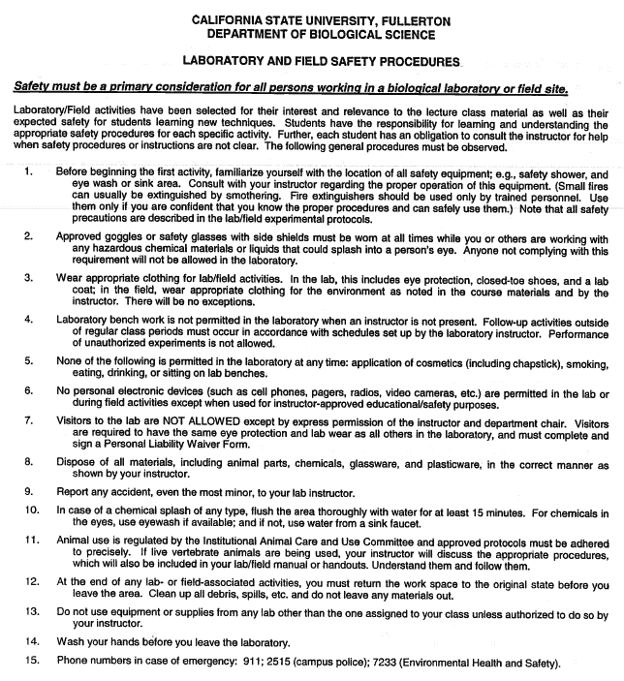

**I have read and will abide by all of the above lab safety regulations.**

BIOL _     ___ Sect# _     __ Class#_     ____ Date_     _____ CWID# __     _________

STUDENT Signature _____________________________ Print Name ___     ______________

Approved 10 Sep 2004; #7 updated Dec 04