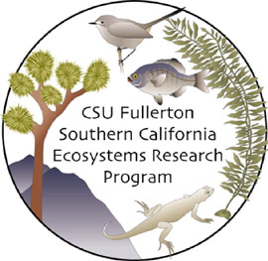
SCERP Scholar
Presentation, Award, & Scholarship Report Form

Did you make a presentation at a conference, win an award, or receive a scholarship? If so, please fill out this form for each instance and turn it in to Bill Hoese. Be sure to provide all pertinent information (e.g., your name, date of event, location, source, title, conference name, poster/oral presentation, amount of scholarship, length of award, etc.). It is essential that you turn in one of these forms for each event so we can report our progress and your successes back to NSF! Please turn one of these forms within 20 days of the event. Thanks.

Your name:
Date of event:
Type of event and name (e.g., SACNAS; Boeing Scholarship; REU ):
Location (e.g., Kansas City, MO; CSUF):
Title (e.g., poster title, talk title):

Funding source:
Amount:
Other pertinent information:

