***Presidents & Treasurers are able to Create Events within TitanLink. Additional members can be given access to create events by being added as Event Planners within an organization.***

***Presidents are the only officer that can grant this access.***

***Steps***

1. **Visit** [**www.fullerton.edu/TitanLink**](http://www.fullerton.edu/TitanLink)
2. **Sign In to TitanLink using your Fullerton Portal username and password**
3. **Select the Organization in which you are the President and would like to add Event Planners**



1. **Choose “Roster” for your Organization**



1. **Select “Manage Roster”**



1. **You will see a list of your members, next to the member you would like to add as an Event Planner, select “Edit Positions”**

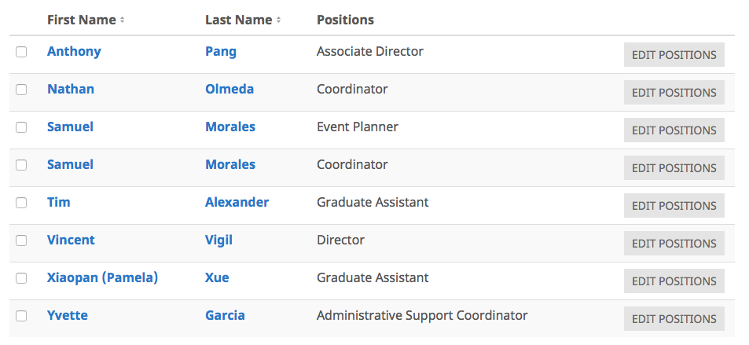

1. **Check the box next to the “Event Planner” position to add this role to the member. Click “Save”**

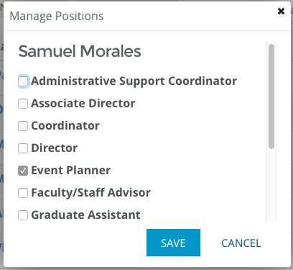

**Repeat as necessary for any members who should have access to create events on behalf of your organization.**

**A member who is assigned as an Event Planner is only able to create events on behalf of that particular organization.**